Unit 1 Practice 1 Name___________________

1. Hit movies According to the Internet Movie Database, Avatar is tops based on box office sales worldwide. The following table displays data on several popular movies.

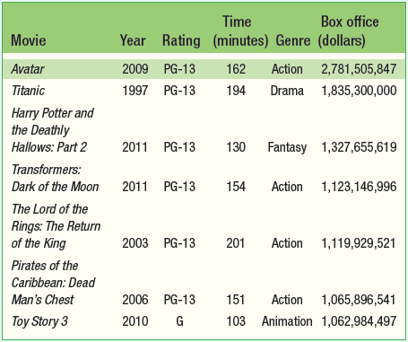

(a) What individuals does this data set describe? Movies

(b) Clearly identify each of the variables. Which are quantitative?

Quantitative: Time, Box office sales, (Year)

Categorical: Rating, Genre, Year

(c) Describe the individual in the highlighted row.

 The movie Avatar, released in 2009, was rated PG-13. It is an action film, runs 162 minutes, and has box office sales of $2,781,505,847.

1. I'd die without my phone! In a survey of over 2000 U.S. teenagers by Harris Interactive, 47% said that “their social life would end or be worsened without their cell phone.” One survey question asked the teens how important it is for their phone to have certain features. The figure below displays data on the percent who indicated that a particular feature is vital.

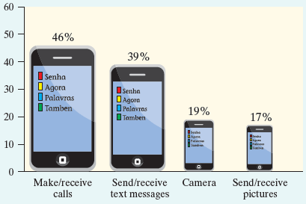

(a) Explain how the graph gives a misleading impression.

(a) The “bars” are different widths. For example, the bar for “send/receive text messages” should be roughly twice the size of the bar for “camera” when it is actually about 4 times as large.

(b) Would it be appropriate to make a pie chart to display these data? Why or why not?

(b) No, because they do not describe parts of a whole. Students were free to answer in more than one category.

(c) Make a graph of the data that isn’t misleading.

(c) A bar graph is given below.

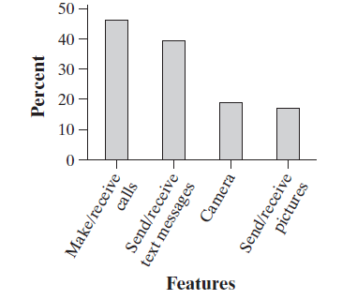

1. Is there a relationship between Facebook use and age among college students? The following two-way table displays data for the 219 students who responded to the survey

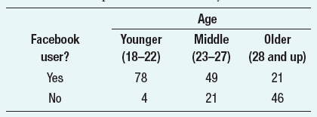

1. What percent of the students who responded were Facebook users? Is this percent part of a marginal

distribution or a conditional distribution? Explain.

(b) What percent of the younger students in the sample were Facebook users? What percent of the Facebook

users in the sample were younger students?

1. Determine whether there is an association between Facebook use and age. Give appropriate graphical and numerical evidence to support your answer.

|  |  |  |  |  |
| --- | --- | --- | --- | --- |
| Facebook user | Younger | Middle | Older |  |
| Yes | 78 | 49 | 21 | **148** |
| No | 4 | 21 | 46 | **71** |
|  | **82** | **70** | **67** | **219** |

(a) 148/219 = 67.6%. Marginal distribution, because it is part of the distribution of one variable for all categories of the other variable.

(b) 78/82 = 95.1% of the younger students were Facebook users. 78/148 = 52.7% of the Facebook users were younger.

(c) There does appear to be an association between age and Facebook status. From both the table and the graph given below, we can see that as age increases, the percent of Facebook users decreases. For younger students, about 95% are members. That drops to 70% for middle students and drops even further to 31.3% for older students.

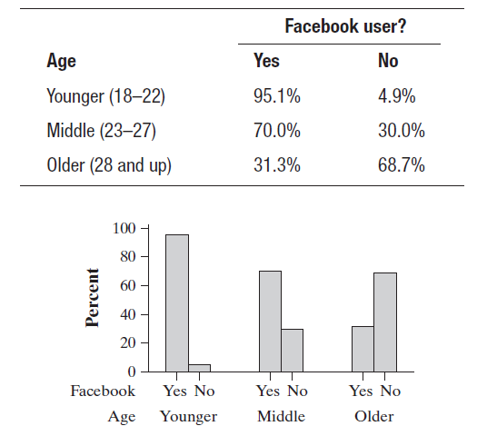

4. In 1798, the English scientist Henry Cavendish measured the density of the earth several times by careful work with a torsion balance. The variable recorded was the density of the earth as a multiple of the density of water. Here are Cavendish’s 29 measurements:

5.50 5.61 4.88 5.07 5.26 5.55 5.36 5.29 5.58 5.65

5.57 5.53 5.62 5.29 5.44 5.34 5.79 5.10 5.27 5.39

5.42 5.47 5.63 5.34 5.46 5.30 5.75 5.68 5.85

(a) Present these measurements graphically in a stemplot.

(b) Discuss the shape, center, and spread of the distribution. Are there any outliers?

(c) What is your estimate of the density of the earth based on these measurements? Explain.

(a)

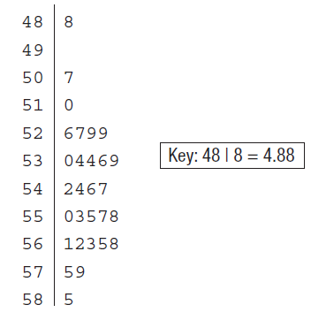

(b) The distribution is roughly symmetric with one possible outlier at 4.88. The center of the distribution

is between 5.4 and 5.5. The densities vary from 4.88 to 5.85. (You need to write in context)

(c) Because the distribution is roughly symmetric, we can use the mean to estimate the Earth’s density to be about 5.45 times the density of water.