Unit 1 Quiz 1 Name­­­­­­___________________

Fill in your multiple-choice answers.

|  |  |  |  |  |  |  |  |  |  |  |
| --- | --- | --- | --- | --- | --- | --- | --- | --- | --- | --- |
| 1 | 2 | 3 | 4 | 5 | 6 | 7 | 8 | 9 | 10 | 11 |
|  |  |  |  |  |  |  |  |  |  |  |

1. You record the age, marital status, and earned income of a sample of 1463 women. The number and

type of variables you have recorded is

(a) 3 quantitative, 0 categorical.

(b) 4 quantitative, 0 categorical.

(c) 3 quantitative, 1 categorical.

(d) 2 quantitative, 1 categorical.

(e) 2 quantitative, 2 categorical.

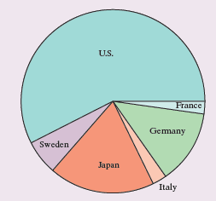2. Consumers Union measured the gas mileage in miles per gallon of 38 vehicles from the same model year on a special test track. The pie chart provides information about the country of manufacture of the model cars tested by Consumers Union. Based on the pie chart, we conclude that

(a) Japanese cars get significantly lower gas mileage than cars from other countries.

(b) U.S. cars get significantly higher gas mileage than cars from other countries.

(c) Swedish cars get gas mileages that are between those of Japanese and U.S. cars.

(d) cars from France have the lowest gas mileage.

(e) more than half of the cars in the study were from the United States.

3. Which of the following bar graphs is equivalent to the pie chart in Question 2? (b)

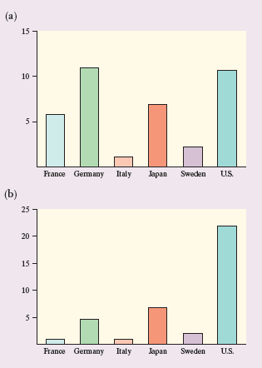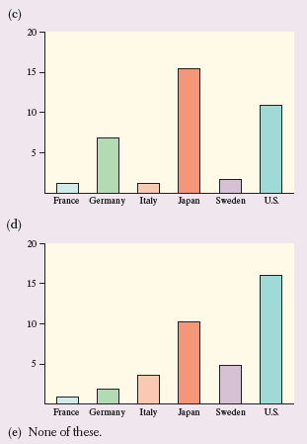

4. Earthquake intensities are measured using a device called a seismograph, which is designed to be most

sensitive to earthquakes with intensities between 4.0 and 9.0 on the Richter scale. Measurements of nine

earthquakes gave the following readings:

4.5 L 5.5 H 8.7 8.9 6.0 H 5.2

where L indicates that the earthquake had an intensity below 4.0 and an H indicates that the earthquake

had an intensity above 9.0. The median earthquake intensity of the sample is

(a) 5.75.

(b) 6.00.

(c) 6.47.

(d) 8.70.

(e) Cannot be determined. L 4.5 5.2 5.5 6.0 8.7 8.9 H H

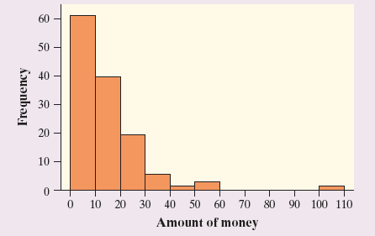*Questions 5 and 6 refer to the following setting.* In a statistics class with 136 students, the professor records how much money (in dollars) each student has in his or her possession during the first class of the semester. The histogram shows the data that were collected.

5. The percentage of students with less than $10 in their possession is closest to

1. 30%. (b) 35%. (c) 45%. (d) 60%. (e) 70%.

6. Which of the following statements about this distribution is *not* correct?

(a) The histogram is right-skewed.

(b) The median is less than $20.

(c) The *IQR* is $35. (97.5th-32.5th)

(d) The mean is greater than the median.

(e) The histogram is unimodal.

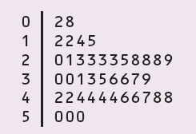

7. Forty students took a statistics examination having a maximum of 50 points. The score distribution is

given in the following stem-and-leaf plot:

The third quartile of the score distribution is equal to

1. 45. (b) 44. (c) 43. (d) 32. (e) 23.

8. The mean salary of all female workers is $35,000. The mean salary of all male workers is $41,000. What

must be true about the mean salary of all workers?

(a) It must be $38,000.

(b) It must be larger than the median salary.

(c) It could be any number between $35,000 and $41,000.

(d) It must be larger than $38,000.

(e) It cannot be larger than $40,000.

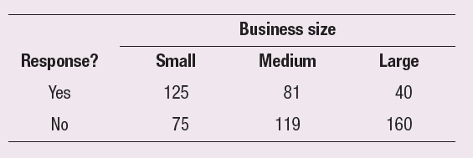*Questions 9 and 10 refer to the following setting.* A survey was designed to study how business operations vary according to their size. Companies were classified as small, medium, or large. Questionnaires were sent to 200 randomly selected businesses of each size. Because not all questionnaires in a survey of this type are returned, researchers decided to investigate the relationship between the response rate and the size of the business.

The data are given in the following two-way table:

9. What percent of all small companies receiving questionnaires responded?

1. 12.5% (c) 33.3% (e) 62.5% (b) 20.8% (d) 50.8%

10. Which of the following conclusions seems to be supported by the data?

(a) There are more small companies than large companies in the survey.

(b) Small companies appear to have a higher response rate than medium or big companies.

(c) Exactly the same number of companies responded as didn’t respond.

(d) Overall, more than half of companies responded to the survey.

(e) If we combined the medium and large companies, then their response rate would be equal to that of the small companies.

11. An experiment was conducted to investigate the effect of a new weed killer to prevent weed growth in onion

crops. Two chemicals were used: the standard weed killer (C) and the new chemical (W). Both chemicals were tested at high and low concentrations on a total of 50 test plots. The percent of weeds that grew in each plot was recorded. Here are some boxplots of the results. Which of the following is *not* a correct statement

about the results of this experiment?

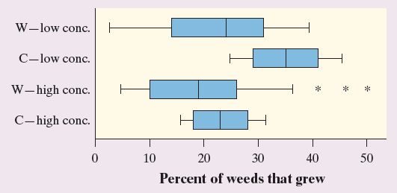

(a) At both high and low concentrations, the new chemical (W) gives better weed control than the standard weed

killer (C).

(b) Fewer weeds grew at higher concentrations of both chemicals.

(c) The results for the standard weed killer (C) are less variable than those for the new chemical (W).

(d) High and low concentrations of either chemical have approximately the same effects on weed growth.

(e) Some of the results for the low concentration of weed killer W show fewer weeds growing than some of the

results for the high concentration of W.

Free response questions

12. A study among the Pima Indians of Arizona investigated the relationship between a mother’s diabetic

status and the appearance of birth defects in her children. The results appear in the two-way table below.

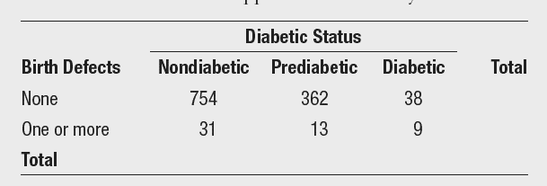

(a) Fill in the row and column totals in the margins of the table.

(b) Compute (in percents) the conditional distributions of birth defects for each diabetic status.

(c) Display the conditional distributions in a graph. Don’t forget to label your graph completely.

(d) Do these data give evidence of an association between diabetic status and birth defects? Justify your answer.

13. During the early part of the 1994 baseball season, many fans and players noticed that the number of

home runs being hit seemed unusually large. Here are the data on the number of home runs hit by

American League and National League teams in the early part of the 1994 season:

American League: 35 40 43 49 51 54 57 58 58 64 68 68 75 77

National League: 29 31 42 46 47 48 48 53 55 55 55 63 63 67

Compare the distributions of home runs for the two leagues graphically and numerically. Write a few sentences summarizing your findings.

