Unit 1 Concept Check 2 Name____________________

1. When you describe the distribution or compare the distributions of a quantitative variable, you need to examine the ____shape_____, ____center____, _____spread_____, and______ outlier_______.
2. Which of the following shapes is right-skewed? Right-skewed is also called___ positively skewed_________.

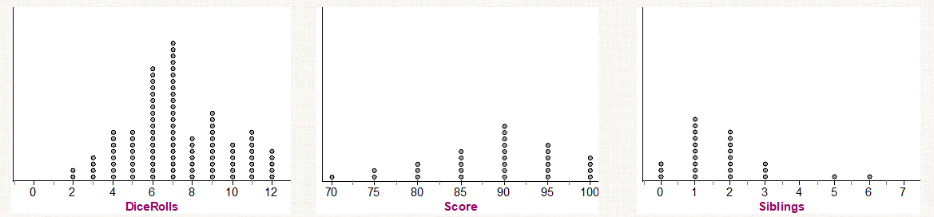

1. When you draw a stemplot, you also need to write out the “Key”. What is the “Key”?

The “Key” explains in context what the stems and leaves represent.

1. Write down the formula for a sample Standard Deviation.



1. When would you choose Median and IQR/Range as measures of center and spread instead of Mean and Standard Deviation? Why?

When describing a skewed distribution or distribution with strong outliers, it is better to use median and IOR/Range as the measures of center and spread, because mean and standard deviation are sensitive to extreme observations.