Unit 1 Concept Check 1 Name__________________

1. What is statistics?

Statistics is the science of data. It is the study of collecting, organizing, analyzing, and interpreting data.

1. A variable of a particular individual is any characteristic of that individual
2. There are two types of variables which are (1) ___categorical variable__ and (2) _quantitative variable_____.

The meaning of

1. is the variable that places an individual into groups
2. is the variable that takes numerical values for which it to makes sense to find an average

The variables in the next question are __country/region___and ____vehicle color___. They belongs to type_(1)__.

1. The bar graph below shows the preference for vehicle colors in the US and Europe in recent years. (1) Is the distribution marginal or conditional? Why? Use the definition to explain. (2) Compare and describe the pattern within context.

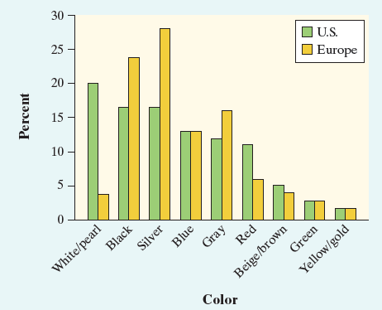

1. The side-by-side bar graph depicts two distributions of favor in vehicle colors for two countries, the US and Europe respectively. The variables in each distribution are describing values for a certain value of the other category, so the distributions are conditional. Marginal distributions can only consider one categorical variable at a time, so the graph should not be a side-by-side bar graph.
2. Based on the sample distribution, White, Black, and Silver are the three most popular colors of cars for the US people, especially White cars, occupying almost 20% of all the vehicle colors. On the other hand, in Europe, only about 4% of people favor White cars, Black and Silver still remain the most popular car colors. Brown, Green, and Yellow are not as popular in both countries compared to other car colors.