**The Process of Science**

Science is often described—although somewhat simplistically—as a process that follows the **scientific method**:

1. Observe phenomena that stimulate a question or problem.

2. Offer an educated guess—a hypothesis—about the answer.

3. Design an experiment to test the hypothesis.

4. Predict the outcome of the experiment if the hypothesis is supported and if the hypothesis is not supported.

5. Conduct the experiment and observe what actually happens.

6. Draw a conclusion or formulate a simple generalized “rule” based on the results of the experiment.

In practice, however, science doesn’t always work through experimentation; in many fields of science, data collection through observation of a phenomenon is the basis of knowledge. In some regards science is best thought of as a process—or perhaps even as an attitude—for gaining knowledge. The scientific approach is based on observation, experimentation, logical reasoning, skepticism of unsupported conclusions, and the willingness to modify or even reject long-held ideas when new evidence contradicts them. For example, up until the 1950s most Earth scientists thought it impossible that the positions of continents could change over time. However, by the late 1960s enough new evidence had been gathered to convince them that their earlier ideas were wrong—the configuration of continents has changed and continues to change!

Although the term “scientific proof” is sometimes used by the general public, strictly speaking, science does not “prove” ideas. Instead, science works by eliminating alternative explanations—eliminating explanations that aren’t supported by evidence. In fact, in order for a hypothesis to be “scientific,” there must be some test or possible observation that could disprove it. If there is no way to disprove an idea, then that idea simply cannot be supported by science.

The word “theory” is often used in everyday conversation to mean a “hunch” or conjecture. However, in science a theory represents the highest order of understanding for a body of information—a logical, well-tested explanation that encompasses a wide variety of facts and observations. Thus, the “theory of plate tectonics” represents an empirically supported, broadly accepted, overarching framework for understanding processes that operate within Earth.

The acceptance of scientific ideas and theories is based on a preponderance of evidence, not on “belief” and not on the pronouncements of “authorities.” New observations and new evidence often cause scientists to revise their conclusions and theories or those of others. Much of this self-correcting process for refining scientific knowledge takes place through peer-reviewed journal articles. Peers—that is, fellow scientists—scrutinize a scientific report for sound reasoning, appropriate data collection, and solid evidence before it is published; reviewers need not agree with the author’s conclusions, but they strive to ensure that the research meets rigorous standards of scholarship before publication.

Because new evidence may prompt scientists to change their ideas, good science tends to be somewhat cautious in the conclusions that are drawn. For this reason, the findings of many scientific studies are prefaced by phrases such as “the evidence suggests” or “the results most likely show.” In some cases, different scientists interpret the same data quite differently and so disagree in their conclusions. Frequently, studies find that “more research is needed.” The kind of uncertainty sometimes inherent in science may lead the general public to question the conclusions of scientific studies—especially when presented with a simple, and perhaps comforting, nonscientific alternative. It is, however, this very uncertainty that often compels scientists to push forward in the quest for knowledge and understanding!

**The Geographic Grid—Latitude and Longitude**

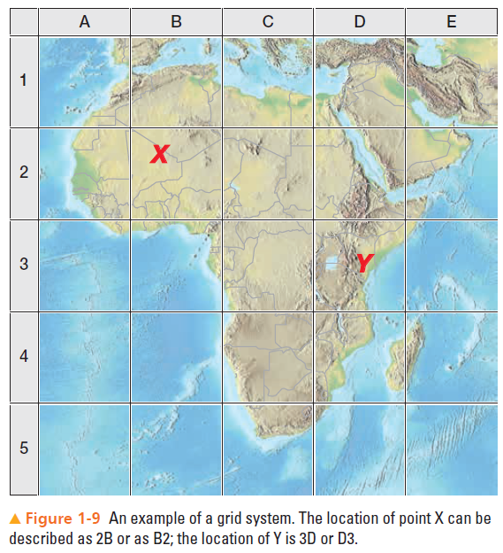Any understanding of the distribution of geographic features over Earth’s surface requires some system of accurate location. The simplest technique for achieving this is a grid system consisting of two sets of lines that intersect at right angles, allowing the location of any point on the surface to be described by the appropriate intersection (Figure 1-9). Such a rectangular grid system has been reconfigured for Earth’s spherical surface.

If our planet were a non-rotating body, the problem of describing location would be more difficult than it is: imagine trying to describe the location of a particular point on a perfectly round, perfectly clean ball. Because Earth does rotate, we can use its rotation axis (自转轴) as a starting point to describe locations.

Earth’s rotation axis (地球自转轴=地轴) is an imaginary line passing through Earth that connects the points on the surface called the North Pole and the South Pole 南北极 (Figure 1-10). Furthermore, if we visualize an imaginary plane passing through Earth halfway between the poles and perpendicular(垂直) to the axis of rotation, we have another valuable reference feature: the plane of the equator (赤道面). Where this plane intersects Earth’s surface is the imaginary midline of Earth, simply called *the equator* 赤道. We use the North Pole, South Pole, rotational axis, and equatorial plane as natural reference features for measuring and describing locations on Earth’s surface.

Although we could visualize an unlimited number of parallels, seven latitudes are of particular significance in a general study of Earth (Figure 1-14):

1. Equator, 0° (Figure 1-15)

2. Tropic of Cancer, 23.5° N 北回归线，国内一般说23°26′

3. Tropic of Capricorn, 23.5° S 南回归线，23°26′

4. Arctic Circle, 66.5° N 北极圈，66°34′

5. Antarctic Circle, 66.5° S 南极圈，66°34′

6. North Pole, 90° N，北极

7. South Pole, 90° S，南极

**Earth–Sun Relations and the Seasons**

Nearly all life on Earth depends on solar energy; therefore, the relationship between Earth and the Sun is of vital importance. Because of the perpetual motions of Earth, this relationship does not remain the same throughout the year. We begin with a description of Earth movements and the relationship of Earth’s axis to the Sun, and then we offer an explanation of the change of seasons.

**Earth Movements**

Two basic Earth movements—its daily rotation on its axis and its annual revolution around the Sun—along with the inclination and “polarity” of Earth’s rotation axis, combine to change Earth’s orientation to the Sun—and therefore produce the change of seasons.

**Earth’s Rotation on Its Axis 地球绕着地轴的自转**

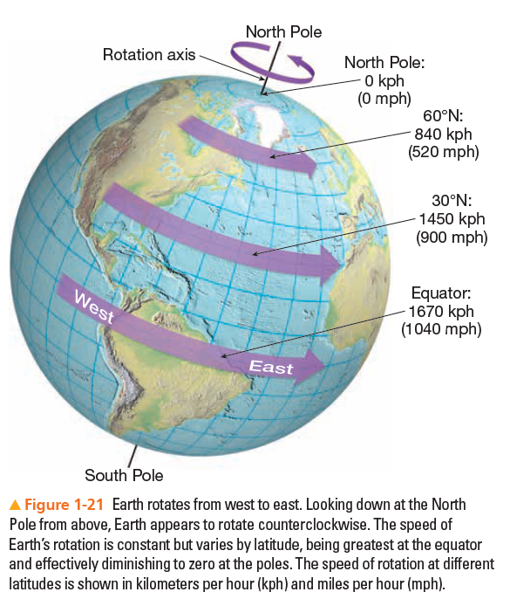Earth rotates from west to east on its **axis** 地轴 (Figure 1-21), an imaginary line that extends from the North Pole to the South Pole, a complete rotation requiring 24 hours with respect to the sun. (From the vantage point of looking down at the North Pole from space, Earth is rotating counterclockwise.) The Sun, the Moon, and the stars appear to rise in the east and set in the west—this is, of course, an illusion created by the steady eastward spin of Earth.

Rotation accounts for our alternating days and nights. This can be demonstrated by shining a light at a globe while rotating the globe slowly toward the east. You can see that half the sphere is always illuminated while the other half is not and that new points are continually moving into the illuminated section of the globe (day) while others are moving into the darkened sector (night). This corresponds to Earth’s rotation and the sun’s energy striking Earth. While one half of Earth receives the light and energy of solar radiation, the other half is in darkness. The dividing line that separates day from night is known as **the circle of illumination 晨昏线** (figure 1.20), and it moves from the east toward the west.

Rotation causes all parts of Earth’s surface except the poles to move in a circle around Earth’s axis. Although the speed of rotation varies by latitude (see Figure 1-21), it is constant at any given place on Earth.

（灰底为较难的选读部分）

Earth’s rotational velocity at the surface varies with a location’s distance from the equator (the imaginary circle around Earth halfway between the two poles). Every location on Earth undergoes a complete rotation (360°) in 24 hours, or 15° per hour. However, the **linear velocity线速度** depends on the distance (not the angle) covered during that 24 hours. The linear velocity at the poles is zero. You can see this by spinning a globe with a postage stamp affixed to the North Pole. The stamp rotates 360° but covers no distance and therefore has no linear velocity. If you place the stamp anywhere between the North and South Poles, however, it will cover a measurable distance during one rotation of the globe. Earth’s highest linear velocity is at the equator, where the distance traveled by a point in 24 hours is greatest. At Kampala, Uganda, near the equator, the velocity is about 460 meters (1,500 ft) per second, or approximately 1,660 kilometers (1,038 mi) per hour (■ Fig. 1.21). In comparison, at St. Petersburg, Russia (60°N latitude), where the distance traveled during one complete rotation of Earth is about half that at the equator, Earth rotates about 830 kilometers (519 mi) per hour.

We are unaware of the speed of rotation because the **angular velocity 角速度** is constant for each place on Earth’s surface, the atmosphere rotates with Earth, and there are no nearby objects, either stationary or moving at a different rate with respect to Earth, to which we can compare Earth’s movement. Without these kinds of references, we cannot perceive the speed of rotation.

**Earth’s Revolution around the Sun** 地球绕日公转

While Earth rotates on its axis, it also orbits around the sun in a slightly elliptical orbit at an average distance from the sun of about 150 million kilometers. Earth’s movement around the sun is called **revolution**公转. Each revolution takes 365 days, 5 hours, 48 minutes, and 46 seconds, or 365.242199 days. This is known officially as the *tropical year* and for practical purposes is usually simplified to 365.25 days. Because of the difficulty of dealing with a fraction of a day, it was decided that a year would have 365 days, and every fourth year, called a l*eap year* 闰年, has an extra day added as February 29.

The path followed by Earth in its journey around the Sun is not a true circle but an *ellipse* (Figure 1-22). Because of this elliptical orbit, the Earth–Sun distance is not constant. Rather, it varies from approximately 147,100,000 kilometers at the closest or *perihelion* position近日点 (peri is from the Greek and means “around” and helios means “Sun”) on about January 3, to approximately 152,100,000 kilometers at the farthest or *aphelion position* 远日点(ap is from the Greek and means “away from”) on about July 4. The average Earth–Sun distance is defined as one astronomical unit (1 AU)—about 149,597,871 kilometers.

Earth is 3.3 percent closer to the Sun during the Northern Hemisphere winter than during the Northern Hemisphere summer, an indication that variations in the distance between Earth and the Sun do not cause the change of seasons. Instead, two additional factors in the relationship of Earth to the Sun—inclination and polarity—work together with rotation and revolution to produce the change of seasons.

**Inclination of Earth’s Axis: 地轴倾斜；**angle of inclination**地轴倾角**

Earth’s rotation axis is not perpendicular to the imaginary plane defined by Earth’s orbital path around the Sun, called *the plane of the ecliptic 黄道平面（地球公转轨道平面）* (see Figure 1-22). Rather, the axis is tilted about 23.5° from the perpendicular (Figure 1-23) and maintains this tilt throughout the year. This tilt is referred to as the *inclination of Earth’s axis*.

**Polarity of Earth’s Axis**: 地轴极性（即地轴始终指北）

Not only is Earth’s rotation axis inclined relative to its orbital path, but also no matter where Earth is in its orbit around the Sun, the axis always points in the same direction relative to the stars—toward the North Star, Polaris (Figure 1-24). This characteristic is called *the polarity of Earth’s axis* 地轴极性(or *parallelism*, because as Earth revolves around the sun, Earth’s axis remains parallel to its former positions. That is, at every position in Earth’s orbit during a year, the axis remains pointed toward the same spot in the sky)

The combined effects of rotation, revolution, inclination, and polarity result in the seasonal patterns experienced on Earth. Notice in Figure 1-24 that at one point in Earth’s orbit, during the Northern Hemisphere summer, the North Pole is oriented most directly toward the Sun, whereas six months later, during the Northern Hemisphere winter, the North Pole is oriented most directly away from the Sun. This is the most fundamental feature of the annual march of the seasons.

**The Annual March of the Seasons**

During a year, the changing relationship of Earth to the Sun results in variations in day length and in the angle at which the Sun’s rays strike the surface of Earth. These changes are most obvious in the mid- and high latitudes, but important variations take place within the tropics as well.

As we discuss the annual march of the seasons, we pay special attention to three conditions:

1. The latitude receiving the vertical rays of the Sun (rays striking the surface at a right angle), referred to as the *declination of the Sun*. 某个纬度获得的直射太阳光，叫做太阳高度角/太阳直射角

2. The *solar altitude* (the height of the noon Sun above the horizon) at different latitudes. 正午太阳高度角

3. The length of day (number of daylight hours) at different latitudes. 昼长

Initially, we emphasize the conditions on four special days of the year: the March equinox 春分, the June solstice 夏至, the September equinox秋分, and the December solstice 东至 (see Figure 1-24a). As we describe the change of seasons, the significance of the “seven important parallels” discussed earlier will become clear. We begin with the June solstice.

**June Solstice**: On the June solstice, which occurs on or about June 21 (the exact date varies slightly from year to year), Earth reaches the position in its orbit where the North Pole is oriented most directly toward the Sun. On this day, the vertical rays of the Sun strike the Tropic of Cancer, 23.5° north of the equator (Figure 1-24b). Were you at the Tropic of Cancer on this day, the Sun would be directly overhead in the sky at noon (in other words, the solar altitude would be 图示
90°). The Tropic of Cancer marks the northernmost latitude reached by the vertical rays of the Sun during the year.

On the June solstice, the circle of illumination bisects the equator (Figure 1-24b), so on this day the equator receives equal day and night—12 hours of daylight and 12 hours of darkness. However, as we move north of the equator, the portion of each parallel in daylight increases—in other words, day length increases. Conversely, day length decreases as we move south of the equator.

Notice in Figure 1-24b that on the June solstice, the circle of illumination reaches 23.5° *beyond* the North Pole to a latitude of 66.5° N. As Earth rotates, all locations north of 66.5° remain continuously in daylight and so experience 24 hours of daylight. By contrast, all points south of 66.5° S are always outside the circle of illumination and so have 24 continuous hours of darkness. These special parallels defining the equatorward limit of 24 hours of light and dark on the solstices are called the ***polar circles***. The northern polar circle, at 66.5° N, is the Arctic Circle 北极圈; the southern polar circle, at 66.5° S, is the Antarctic Circle 南极圈. The June solstice is called the *summer solstice* 夏至in the Northern Hemisphere and the winter solstice in the Southern Hemisphere. (These are commonly called the “first day of summer” and the “first day of winter” in their respective hemispheres.)

**September Equinox 秋分**: Three months after the June solstice, on about September 22, Earth experiences the September equinox. Notice in Figure 1-24c that the vertical rays of the Sun strike the equator. Notice also that the circle of illumination just touches both poles, bisecting all other parallels— on this day all locations on Earth experience 12 hours of daylight and 12 hours of darkness. (The word “equinox” comes from the Latin, meaning “the time of equal days and equal nights.”) At the equator—and only at the equator— every day of the year has virtually 12 hours of daylight and 12 hours of darkness; all other locations have equal day and night only on an equinox. The September equinox is called the *autumnal equinox* in the Northern Hemisphere and the vernal equinox in the Southern Hemisphere. (These are commonly called the “first day of fall” and the “first day of spring” in their respective hemispheres.)

**December Solstice:** On the December solstice, which occurs on about December 21, Earth reaches the position in its orbit where the North Pole is oriented most directly away from the Sun. The vertical rays of the Sun now strike 23.5° S, the Tropic of Capricorn (Figure 1-24d). Once again, the circle of illumination reaches to the far side of one pole and falls short on the near side of the other pole, so areas north of the Arctic Circle are in continuous darkness, whereas areas south of the Antarctic Circle are in daylight for 24 hours. The relationships between Earth and the Sun on the June solstice and the December solstice are very similar; the conditions in each hemisphere are simply reversed. The December solstice is called the winter solstice in the Northern Hemisphere and the summer solstice in the Southern Hemisphere (the “first day of winter” and the “first day of summer,” respectively).

**March Equinox**: Three months after the December solstice, on approximately March 20, Earth experiences the March equinox. The relationships of Earth and the Sun are virtually identical on the March equinox and the September equinox (Figure 1-24c). The March equinox is called the vernal equinox in the Northern Hemisphere and the autumnal equinox in the Southern Hemisphere (the “first day of spring” and the “first day of fall,” respectively). Table 1-2 summarizes the conditions present during the solstices and equinoxes.

**Seasonal Transitions**

In the preceding discussion of the solstices and equinoxes, we emphasized the conditions on just four special days of the year. It is important to understand the transitions in day length and Sun angle that take place on other days as well.

**Latitude Receiving the Vertical Rays of the Sun**: The vertical rays of the Sun strike Earth only between the Tropic of Cancer and the Tropic of Capricorn. After the March equinox, the vertical rays of the Sun migrate north from the equator, striking the Tropic of Cancer on the June solstice (the day the Sun is highest in the sky for all latitudes north of the Tropic of Cancer). After the June solstice, the vertical rays migrate south, striking the equator again on the September equinox and reaching the Tropic of Capricorn on the December solstice (the day the Sun is lowest in the sky in the Northern Hemisphere). Following the December solstice, the vertical rays migrate northward, reaching the equator once again on the March equinox.

**Day Length**: Only at the equator is day length constant throughout the year—virtually 12 hours of daylight every day of the year. For all regions in the Northern Hemisphere up to the latitude of the Arctic Circle, following the shortest day of the year on the December solstice, the number of hours of daylight gradually increases, reaching 12 hours on the March equinox. After the equinox, day length continues to increase until the longest day of the year, on the June solstice. (During this period, day length is diminishing in the Southern Hemisphere.)

Following the longest day of the year in the Northern Hemisphere, the June solstice, the pattern is reversed: the days get shorter in the Northern Hemisphere—reaching 12 hours on the September equinox. Day length continues to diminish until the shortest day of the year, on the December solstice. (During this period, day length is increasing in the Southern Hemisphere.)

Overall, the annual variation in day length is the least in the tropics and the greatest at high latitudes

**Day Length in the Arctic and Antarctic:** The patterns of day and night in the Arctic and Antarctic deserve special mention. For an observer exactly at the North Pole, the Sun rises on the March equinox and is above the horizon continuously for the next six months—circling the horizon higher and higher each day until the June solstice, after which it circles lower and lower until setting on the September equinox.

Week by week following the March equinox, a growing region surrounding the North Pole experiences 24 hours of daylight—until the June solstice, when the entire region from the Arctic Circle to the North Pole experiences 24 hours of daylight. Following the June solstice, the region of 24 hours of daylight diminishes week by week until the September equinox—when the Sun sets at the North Pole and remains below the horizon continuously for the next six months.

Week by week following the September equinox, the region around the North Pole experiencing 24 hours of darkness grows until the December solstice—when the entire region from the Arctic Circle to the North Pole experiences 24 hours of darkness. Following the December solstice, the region experiencing 24 hours of darkness diminishes week by week until the March equinox—when the Sun again rises at the North Pole.

In the Antarctic region of the Southern Hemisphere, these seasonal patterns are simply reversed.

**Significance of Seasonal Patterns**

Both day length and the angle at which the Sun’s rays strike Earth determine the amount of solar energy received at any particular latitude. In general, the higher the Sun is in the sky, the more effective is the warming. Furthermore, short periods of daylight in winter and long periods of daylight in summer contribute to seasonal differences in temperature in the mid- and high-latitude regions.

Thus, the tropical latitudes are generally always warm because they have high Sun angles and consistent, near-12-hour days all year long. Conversely, the polar regions are consistently cold because they always have low Sun angles—even the 24-hour days in summer do not compensate for the low angle of incidence of sunlight. Seasonal temperature differences are large in the midlatitudes because of sizable seasonal variations in Sun angles and length of day.