**How Do We Classify Climates?**

CLASSIFICATION IS THE PROCESS of grouping similar items together and separating dissimilar items. Items that are similar in some ways can be different in others, and items that are in different groups can have certain similarities. Classifications allow us to examine general patterns, with the caveat that interpretations derived from classified groups are best done cautiously. Classification helps us to seek useful generalizations from this enormous amount of information. Climate can be classified in many ways, with the exact nature of the classification depending upon the research question that is of interest.

The most commonly used indicators for describing the climate of a location or a region are **temperature and precipitation**. The most widely used climate classification Köppen Classification surmised that the annual temperature and precipitation regimes determined the types of natural vegetation. Other influences on plant growth, such as which way a slope faces, the number of consecutive days without precipitation, and the types of soils, have more localized effects and so were not considered by Köppen.

The Köppen climate classification system has five major categories. (see figure on the left) The five categories are further subdivided using a succession of criteria of temperature and the availability of water. In the A, C, and D climate types, the second letter is lowercase and indicates whether the climate is wet year-round (f), has a dry summer (s), has a dry winter (w), or experiences a monsoon (m). The second letter is uppercase for arid and polar climates.

**What are the main controls of these climates?**

The major controls of climate include **latitude, altitude, distribution of land and water, the general circulation patterns of the atmosphere, ocean currents, topography, and storms.** These factors interact, producing the characteristic patterns of temperature, pressure, wind, and moisture of the different climates.

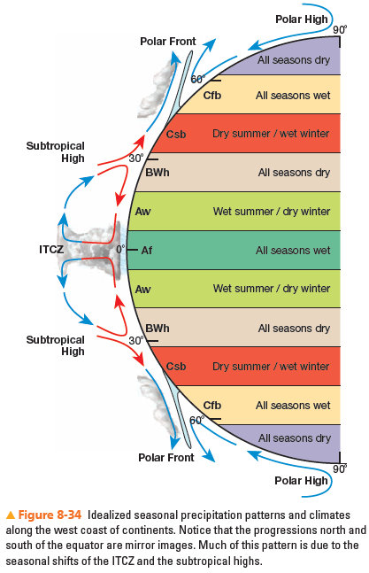**Global Patterns Idealized**

It should be clear to you by now that there is a fairly predictable global pattern of climatic types and that this pattern is based primarily on latitude, position on a continent, and the general circulation of the atmosphere and oceans.

Figure 8-34 summarizes the idealized distribution of the mild (A, B, and C) climates along the west coasts of continents, where the distribution pattern is slightly more regular than along the east coasts. Notice especially the relationship of climate types to the seasonal shifts of the intertropical convergence zone and the subtropical highs.

**Climate and Vegetation**

We acknowledge the dominant vegetation of these plant communities when we classify Earth’s major terrestrial ecosystems, called **biomes 自然带**. The major biome categories (forest 森林, grassland草原, desert沙漠, and tundra苔原) are mapped on the basis of the dominant natural vegetation association that gives each its distinctive environmental character and appearance.

文本

