**Earth Science Lab report: Thermal Effect (热力环流现象) Name**

**Step 1. Beginning questions:**

What will be the main questions that will guide your learning? Your questions should be valid, testable or researchable, and based on observed patterns and/or research. 把你的研究问题写下来，包括一步步聚焦问题的过程。

**Step 2. Hypothesis:**

Considering what you already know about this concept, write a cause and effect statement that explains what you anticipate will occur. Construct a testable hypothesis **with a basic description of the variables**.

* **自变量**What are the independent (cause) variables?
* **因变量** What are the dependent (effect) variables:
* **控制变量** What is the control and the constants to ensure test validity?
* **我觉得**If…then…due to…(Must show cause and effect and should explain why you believe this will occur. Your hypothesis should relate to observation, research, or scientific principle.)

**Step 3. Planning and Carrying Out Investigations**

**Tools:** Water, flat-bottom water tank, probe thermometer, pigments (red and blue), laboratory hot plate, ice cubes

**Method and Steps**（补充完成实验过程）

1. Use probe thermometer to read the temperature of the stilled water in the flat-bottom water tank locating on laboratory hot plates.
2. Heat one side of the water tank while put ice cubes on the other side and read temperature on both sides all the time. Note: the probe should not touch the bottom of the tank or ice cubes.
3. When temperature difference of both sides is above 6℃, drip 4 drops of red pigment on the heating side and 4 drops of blue pigment on the cooling side.
4. Observe how red and blue pigments flow and read temperature on both sides.

**Step 4. Modeling/Observation**

Observe how red and blue pigments flow and draw phenomena **step by step** using two different colors/lines **观察实验过程中彩色水流的方向**，并在下图的对应阶段中用两种不同的颜色/标记标出你的观察结果，按顺序画出水流流向。

**Before During After**

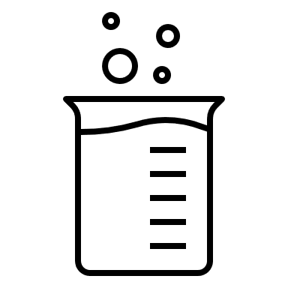

**Step 4. Reading then construct an evidence-based explanation**

|  |  |
| --- | --- |
| **Internal Sources** | **External Sources** |
| In this section you compare your data with *your classmates*. Make sure that you include any examples that may make your ideas clear. | In this section you compare your data with *other scientists*. Use articles, books, or the internet. |
| 在和同学们的结果进行比较后，我发现了（哪些相同、不同和错误） | 在阅读了教材后，我知道了产生这一现象的主要原因是 |

**Reflection: How have my ideas changed?**

* What did you learn about this concept?
* How can you connect this learning to something outside of the classroom?
* How has your thinking changed after the experiment (Understandings, Related Thinking, Connections)?
* Are there any new questions you have about the concept?