**The Nature of Atmospheric Pressure**

Gas molecules, unlike those of a solid or liquid, are not strongly bound to one another. Instead, they are in continuous motion, colliding frequently with one another and with any surfaces to which they are exposed. Consider a container in which a gas is confined (Figure 5-1). The molecules of the gas zoom around inside the container and collide again and again with the walls. The pressure of the gas is the force the gas exerts on the container walls.

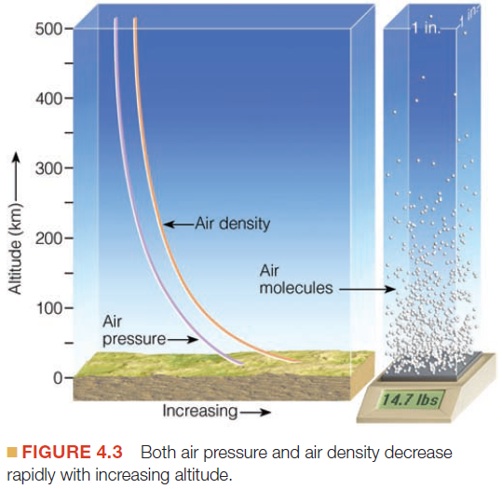The atmosphere is made up of gases that have mass; the atmosphere has weight because this mass is pulled toward Earth by gravity. **Atmospheric pressure** is the force exerted by the weight of these gas molecules on a unit of area of Earth’s surface or on any other body—including yours! At sea level, the pressure (the “weight”) exerted by the atmosphere is about 14.7 pounds per square inch—in S.I. units, about 10 newtons (N) per square centimeter (1 newton is the force required to accelerate a 1-kilogram mass 1 meter per second per second).1 This value decreases with increasing altitude because the farther away you get from Earth and its gravitational pull, the fewer gas molecules are present in the atmosphere.

The atmosphere exerts pressure on every surface it touches. Pressure is exerted equally in all directions—up, down, sideways, and diagonally. Every square centimeter of any exposed surface—animal, vegetable, or mineral—at sea level is subjected to atmospheric pressure (Figure 5-2). We are not sensitive to this ever-present burden of pressure because our bodies contain solids and liquids that are not significantly compressed and air spaces that are at the same pressure as the surrounding atmosphere. In other words, outward pressure and inward pressure within us balance exactly.

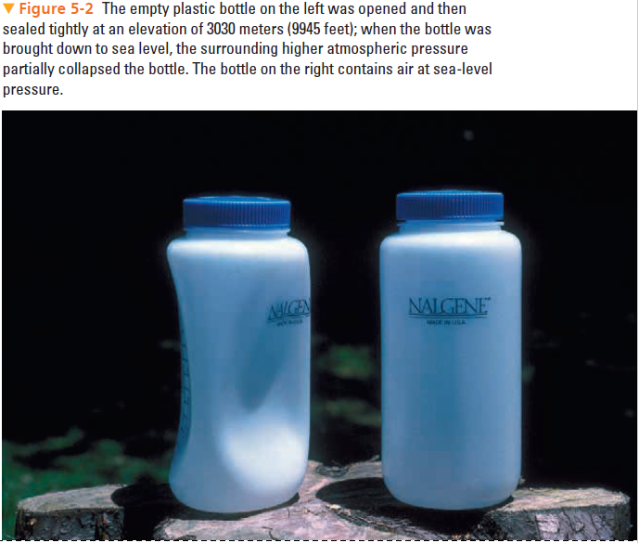

**Density and Pressure Relationships:** Density is the mass of matter in a unit volume. For example, if you have a 10-kilogram cube of material with sides 1 meter long, the density of that material is 10 kilograms per cubic meter (10 kg/m3). The density of solid material is the same on Earth or the Moon or in space; that of liquids varies very slightly from one place to another, but that of gases varies greatly with location. Gas density changes easily because a gas is free to expand as far as the environmental pressure will allow.

For example, if 10 kilograms of gas in a container has a volume of 1 cubic meter, the gas density is 10 kg/m3. If you transfer all the gas to a container having twice the volume (2 cubic meters), the gas expands to fill the larger volume. The same number of gas molecules are now spread through a volume twice as large, so the gas density is half what it was before, or 5 kg/m3 (10 kg divided by 2 cubic meters).

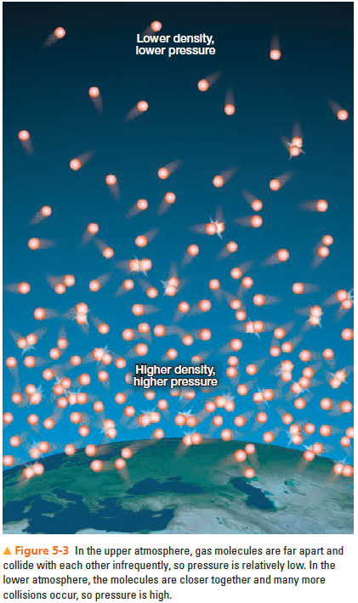The pressure exerted by a gas is proportional to its density. The denser the gas, the greater the pressure it exerts. The atmosphere is held to Earth by the force of gravity, which prevents the gas molecules from escaping into space. At lower altitudes, the gas molecules of the atmosphere are packed more densely (Figure 5-3). Because the density is greater at lower altitudes, there are more molecular collisions and therefore higher pressure. At higher altitudes, the air is less dense and there is a corresponding decrease in pressure.

**Temperature and Pressure Relationships:**

If air is warmed, the speed of molecules increases. This increase in speed produces a greater force to their collisions and results in higher pressure. Therefore, if other conditions remain the same (in particular, if volume is held constant), an increase in the temperature of a gas produces an increase in pressure, and a decrease in temperature produces a decrease in pressure.

You might conclude that the air pressure will be high on warm days and low on cold days. Such is not usually the case, however; warm air is generally associated with low atmospheric pressure and cool air with high atmospheric pressure. Although this seems contradictory, recall that we made the qualifying statement “if other conditions remain the same.” In practice, when air is warmed in the atmosphere, it will expand, which decreases its density. Thus, the increase in temperature may be accompanied by a decrease in pressure caused by the decrease in density.

**Dynamic Influences on Air Pressure: 动能对气压的影响**

Surface air pressure may also be influenced by “dynamic” factors. In other words, air pressure may be influenced by the vertical movement of the air. As a generalization, descending air tends to be associated with relatively high pressure at the surface, whereas rising air tends to be associated with relatively low pressure at the surface.

In short, atmospheric pressure is affected by differences in air density, air temperature, and air movement. It is important for us to be alert to these linkages, but it is often difficult to predict how a change in one variable will affect the others in a specific instance. Nevertheless, we can make some useful generalizations about the factors associated with areas of high pressure and low pressure near the surface:

• Strongly descending air is usually associated with high pressure at the surface—a dynamic high.

• Very cold surface conditions are often associated with high pressure at the surface—a thermal high.

• Strongly rising air is usually associated with low pressure at the surface—a dynamic low.

• Very warm surface conditions are often associated with relatively low pressure at the surface—a thermal low.

Surface pressure conditions usually can be traced to one of these factors being dominant.

**Mapping Pressure with Isobars 气压图**

Pressure differences are shown on a weather map with isolines of equal pressure called **isobars 等压线** (Figure 5-4). The pattern of the isobars reveals the horizontal distribution of pressure in the region under consideration. These highs and lows represent relative conditions: pressure that is higher or lower than that of the surrounding areas. In a similar way, a **ridge 高压脊** is an elongated area of relatively high pressure, whereas a **trough** **低压槽** is an elongated area of relatively low pressure. Notice in Figure 5-4, for example, that a pressure of 1008 millibars could be either “high” or “low,” depending on the pressure of the surrounding areas.

**Pressure Gradients: 水平气压梯度**

As with other types of isolines, the relative closeness of isobars indicates the horizontal rate of pressure change, or pressure gradient. The pressure gradient can be thought of as representing the “steepness” of the pressure “slope” (or more correctly, the abruptness of the pressure change over a distance), a characteristic that has a direct influence on wind, which we discuss next.

**The Nature of Wind**

The atmosphere is virtually always in motion. Air is free to move in any direction, its specific movements being shaped by a variety of factors. Some airflow is weak and brief; some is strong and persistent. **Atmospheric motions often involve**

**both horizontal and vertical movement. Wind refers to horizontal air movement.** Although both vertical and horizontal motions are important in the atmosphere, much more air is involved in horizontal movements than in vertical ones.

**What causes air to move?**

文本

